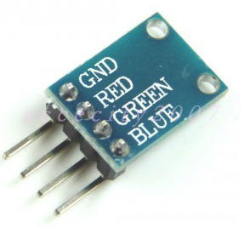
RGB color LED module can let LED emitting different color lights as RED,BLUE,GREEN signal input. This project will change of color assortment and make the LED flashing like rainbow.
STEP 1: connect the module to Arduino as per following graph:

STEP 2: Download the sketch code and load it into arduino.
Run the project and you will see the LED flashing same as following video.

